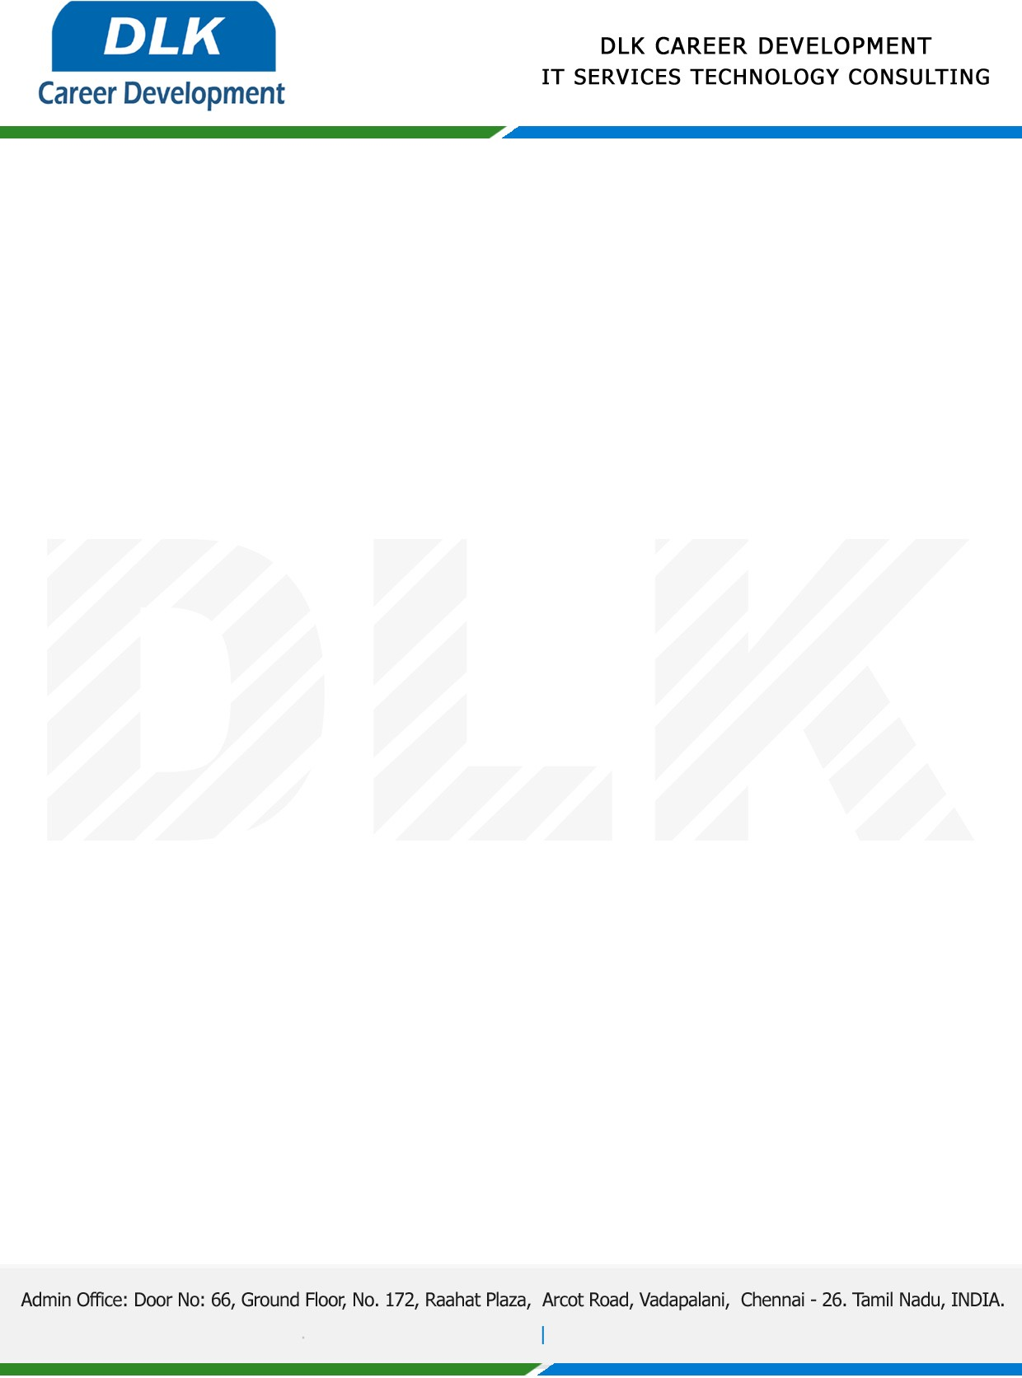

Date: 31/January / 2023

**To**

Department of BE (Computer Science and Engineering),

Head of Department,

Meenakshi Sundararajan Engineering College, Chennai - 600024.

**Sub: Letter of Project Acceptance**

This is to certify that final year students of has accepted the Project Work duration from **01st February 2023** to **31st April 2023** under the domain **“IOT”.** During the Project, all information and data collected from you should be kept confidential.

**Team Members:**

1. MR AKASH S (REG NO:311519104007)
2. MR NANDAKUMAR R (REG NO:311519104037)
3. MR PRASHANTH BASKAR (REG NO:311519104045)

**Topic:** Controlling Smart Appliances using Augmented Reality.

We appreciate your interest in **DLK CAREER DEVELOPMENT**

For **DLK CAREER DEVELOPMENT**

**HR Manager**

**VELMURUGAN J**